Six Step Decision-Making Process (Daft)

Here is the graphic representation of the decision making process:
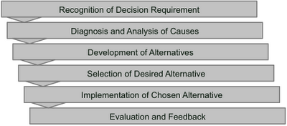
Six Step Decision-Making Process by Daft

Step 1: Recognition of decision requirement.
A decision requirement can be based on a problem or an opportunity. Managers scan the environment regularly, to identify whether there are internal or external factors that require decision action.

Step 2: Diagnosis and analysis of causes.
You will refine your understanding of the actual situation and identify the root causes.

Step 3: Development of alternatives.
Next step is to generate alternatives solutions that will respond to the needs of the situation and correct the underlying causes.
Step 4: Selection of desired alternative.
Choose best alternative which is the solution that best fits the overall goals and values of the organization and achieves the desired results using the fewest resources.
Step 5: Implementation of chosen alternative.
This stage involves the use of managerial, communication, administrative, and persuasive abilities to ensure the choice is carried out. The success of a decision is based on how it is implemented.

Step 6: Evaluation and feedback.
Gather information that tells you whether it was effective in achieving its goals and how well the decision was implemented. Feedback is the part of monitoring that assesses whether a new decision needs to be made, and if so it will help them get back on track.
The process is a good list of verbal phrases of activities without clear activity titles. Each can be changed into a verb. The front end and the backend are complete in my opinion. The middle part is rather thin in the evaluation of criteria how to select the best alternative.

